**EVENT ANNOUNCEMENT EMAIL- PARENTS + COMMUNITY**

**USE HEADER IMAGE BELOW**

Subject: [INSERT SCHOOL NAME] COLLECTED [INSERT MILESTONE]

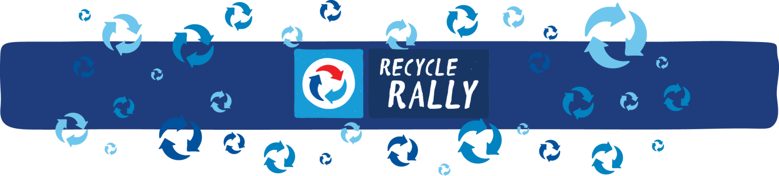

[INSERT SCHOOL NAME] is excited to be participating in PepsiCo’s national Recycle Rally program this year, and even more excited to announce our school has reached our goal of [INSERT RECYCLING MILESTONE].

Our school has been participating in Recycle Rally for [INSERT MONTHS OR YEARS], joining the ranks of hundreds of schools across the country, and it has benefited our school, our students and our community in many ways. For one, we have diverted approximately [INSERT QUANTITY] of bottles and cans from landfills.

We have also helped our students to get excited about recycling and together we are building a generation of lifelong recyclers. We should all be so proud of all that we’ve accomplished – over the course of [INSERT TIME FRAME], we have helped develop a new generation of environmental champions!

So we are excited to celebrate and invite you to join us for:

[INSERT EVENT DETAILS]

We hope you’ll join us in celebrating and continuing to strengthen the recycling program at our school.

[INSERT SIGNATURE for EMAIL SENDER]