EVENT ANNOUNCEMENT EMAIL- STAFF AND STUDENTS
PLEASE USE HEADER IMAGE BELOW

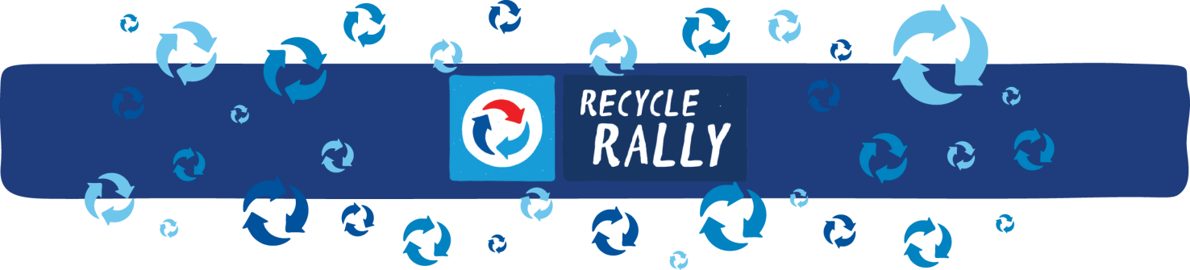

Good [MORNING or AFTERNOON or EVENING] staff,

Let’s get ready to … RECYCLE! With the start of another year comes the start of our involvement in PepsiCo’s Recycle Rally program! PepsiCo Recycle Rally is a free, nationwide program that provides resources and incentives to inspire K-12 students to recycle. It also provides opportunities to earn a wide array of prizes and rewards.

Join us for a special kickoff event that will include:
[INSERT WHAT THE EVENT WILL HOLD, i.e. games, refreshments, speakers etc.].

Please bring your classrooms’ and students’ plastic bottles and aluminum cans, and you’ll be entered into a raffle to win [INSERT PRIZE]!

WHO: [INSERT SCHOOL] students and staff
WHAT: Recycle Rally Kickoff Event!
WHERE: [INSERT ROOM IN SCHOOL] [i.e. gym, cafeteria, classroom]
WHEN: [INSERT DATE + TIME]
WHY: Come help [INSERT SCHOOL] kickoff our Recycle Rally Program, and become one step closer to reaching our recycling goals!

Bring plastic bottles or aluminum cans to recycle to be entered to win a prize!

[INSERT SIGNATURE for EMAIL SENDER]

