**EVENT ANNOUNCEMENT EMAIL- PARENTS**

**PLEASE USE HEADER IMAGE BELOW**

Subject: Help [INSERT SCHOOL NAME] In Our Recycle Rally Journey Today!

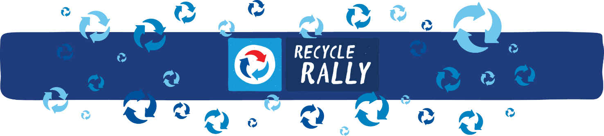

Parents,

[INSERT SCHOOL NAME] is excited to be participating in the Recycle Rally competition again this year, and we could use your help to become one step closer to our recycling goals!

**What is PepsiCo’s Recycle Rally?**

* Recycle Rally is a nationwide program designed to raise awareness of recycling in K-12 schools.
* The program teaches students about the importance of recycling and inspires them to make recycling a part of their daily lives.
* By participating, schools have the opportunity to set and achieve recycling goals, utilize effective educational tools, and connect with a national school recycling network.
* Schools can earn rewards points for each plastic bottle* and can recycled and can redeem the points for prizes and merchandise to help the school.

**How can you help [INSERT SCHOOL] on their Recycle Rally journey?**

* [INSERT SCHOOL] is hosting a community-wide recycling drive [INSERT DATE, TIME, PLACE].
* Send your kids to school with empty aluminum cans and plastic bottles to donate to the drive.
* Invite family, friends, and members of the community to donate their aluminum cans and plastics bottles.

**What’s in it for the students and school?**

* Increases recycling awareness and action in their daily lives to make an impact on the environment
* Provides opportunity for team collaboration and leadership skills
* Involves school groups and broader community
* Fosters schools spirit and pride for community

**We hope you consider helping [INSERT SCHOOL] become one step closer to our recycling goals!**

[INSERT SIGNATURE for EMAIL SENDER]

*Plastic #1 (PETE) & #2 (HDPE) beverage bottles